Title
Your name, names of all lab partners (if any)
(no need for a cover sheet, name of instructor or class name as you submit this to the right class and section and the date is the submission date, but you can include one)
(Lab outcomes: learn and practice spreadsheet techniques and methods for scientific writing)

Abstract
This document outlines the format of the lab report and describes the Excel assignment. The abstract should be a short paragraph that very briefly includes the experiment objective, method, result, and conclusion. After skimming the abstract, the reader should be able to decide whether they want to keep reading your work. Both the format of the report and the error analysis are to be followed. Note that abstract is not just the introduction and conclusion combined, but rather the whole experiment in short including the results.

Introduction
This section should normally start with some background information on the topic of the lab. Historical background is fine, such as the history of discovery or first measurement of the value, etc. The motivation for doing the experiment should follow. Try to avoid separate statement of objective, hypothesis or similar. The motivation paragraph should logically conclude with the necessity of the experiment.
Excel ™ (or a similar spreadsheet software such as Google spreadsheet, OpenOffice Calculator, etc.) is a useful tool to do simple manipulations and visualize data. Always remember that it is not intended to be used as a professional data analysis software and normally should not be used for research that is data intensive or of critical nature. However, Excel-like software is widely used for small projects and in education due to its common availability, simple interface.
The spreadsheet skills are useful in multiple areas outside of science thus the experience with Excel will be beneficial for all students. You can add some practical uses and other descriptions of Office software, may be some history of its creation and development.
Note how the introduction also contains the motivation for the experiment. There should be no statements like ‘hypothesis’ or similar – any motivation for doing the experiment can be included in the Introduction section. Or separated into a section or subsection called ‘Motivation’. It can contain expectations for the results or some hypothesis that is being verified stated indirectly. You should mention what is it you are going to measure in this lab experiment and why it is important in general, may be an example of the application. Do not use ‘because the lab manual instructs so’ or similar pointless statement.

Experimental Setup
Normally, this section describes the experimental setup and should include the photo or a schematic of the setup as well as the text description and the experimental procedure. The schematic can be very simple, such as shown in Figure 1. Briefly describe all the parts of your figure. Descriptions like Figure 1a or Figure 1 (left) can be used. Note the formatting of the figure reference and the caption. No colored text unless required by context.
Ruler
Ball
b)

a)
Figure 1: The experimental setup schematic. A ruler (a) is used to measure the object (b).

The list and details of each section in the lab report are outlined in Table 1. Note that you should not put any words like below, above, last page, etc. The reference to the table, figure, equation, and other numbered items is the only indication where to find the information. The IEEE format should be used for references, such as [1]. The equipment manufacturer may be referenced like [2]. You can have two or more references in a row, for example: [1], [3]. Allow word processing software to do all the numbering and formatting! For the online labs, the relevant screenshot should be used, such as in Figure 2.
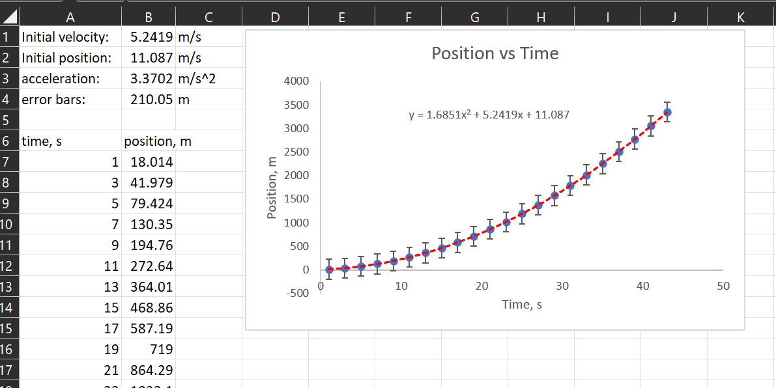
Figure 2: relevant part of the screen! Type some description, such as: The initial settings for the plot are shown.

Table 1: Description of all parts of the report.
Section name | Section content description
Abstract | This is a short summary of the whole report, including the introduction, results, and the conclusion. Include numeric results as appropriate!
Introduction | Give an introduction into the topic of the lab and why are you doing it.
Experimental Setup | Can be also Experiment design, Setup and design, Apparatus, or anything similar. Includes the description of the apparatus used, or the experiment itself with all relevant schematics of the experimental setup. For Tracker labs, a relevant screenshot can be used.
Experimental Results (or Data) | Includes relevant tables (just one per each data type)/graphs of your data. Most likely, this is not raw values but averages with errors or similar. If you have more tables of the same, show only one - do not include the rest in the body of the report, but attach an Appendix at the very end.
Theory/Derivations | Either name is fine. If the lab asks you to derive any equation, or you need to use a set of specific equations, list and describe them here. A separate Derivations section in addition to theory (or as a subsection) can be used if a lengthy derivation is needed from the stated theory. Remember to number all the equations. Do not list equations that are considered ‘common’ knowledge, such as how to find mean or standard deviation. Sometimes such equation should be listed if it’s used explicitly in your calculations.
Analysis | Describe analysis process referring to equations from theory section. Show only organized results (for example, as a table or a plot, etc.). Describe what they are and what do they mean. You may show highlights of some steps of the calculation for a single example if you feel it’s necessary to be shown in detail.  Unless the focus is on the error analysis, it should be included in this section and not separated. ALL LABS SHOULD HAVE ERROR ANALYSIS even if the manual doesn’t directly instruct you to do so.
Conclusion | Restate the result with appropriate errors and comment on it. Or refer to the plot or table with the results if longer than one-two numbers. Comments/discussion should include if the experiment was a success, if the value is near the expected, what was the reason for any deviation and can this experiment be improved if done again.
References | Use IEEE format for the references. You can use reference as part of the text, such as: As described in [1], the result matches with the value from [2] and so on. Avoid quoting actual text from references or keep to as little as possible.
Appendix | Can be Appendix 1, Appendix 2 as needed. Can include anything you wanted to show but it was lengthy or didn’t fit into all previous sections. Normally, you should try to avoid adding an appendix but its ok to include one to your report.

Theory
Consider the equation 1 that described the dependence of position x on time.
$$x=\frac{1}{2}at^{2}+v_{0}t+x_{0}\left(1\right)$$
where $a$ is the acceleration, $t$ is time, $v_{0}$ is the initial velocity and $x_{0}$ is the initial position.
You will use Excel or similar software and the eq. 1 to complete this assignment. You will write the report using the format that is described in this manual.

Analysis
To analyze the eq. 1, you will first set up the problem. For initial position, use the following: =RAND()*100. For initial velocity: =RAND()*20. For the acceleration: =RAND()*5. And for error bars: =(0.4+RAND())*200.
Set up the time column. You can start at 0 or any other value, the increment should be at least 2 seconds, and create at least 50 points. (Hint – don’t just type all numbers manually!). Enter the eq. 1 into the column called position or distance (remember units for each!! Remember static cells with $$). Make the scatter plot – no connecting lines etc., only dots. Set the error bars to the value in ‘error bars’. Add trendline (what type should it be and why?). Show the fit equation. Do the fit parameters correspond to the ones that you set initially? Remember to label the axis! All helpful hints are in the video that is provided. Other resources also exist!
Hint – if the resulting plot doesn’t look like the Figure 2 because error bars are too small, or some other random values didn’t work out nice – try pressing F9 key few times (on some laptops it could be Fn+F9).
The resulting plot should be inserted here, at the end of analysis section. Remember the caption. Make some comments as necessary and a plot description. Only the plot here – not the screenshot, you can copy and paste between Office applications.

Conclusion
This article describes the format for the lab report as well as the initial error analysis and propagation. It highlights the use of captions, references, formatting of equations and provides assignment to be completed in Excel.

References

[1] | L. J. Bignell at al., "Characterization and Modeling of a Water-based Liquid Scintillator," Journal of Instrumentation, IOP Publishing, vol. 10, p. 12009, 12/2015.
[2] | Bivar Inc., 4 Thomas, Irvine, CA 92618, USA.
[3] | C.W. Walter, "The Super-Kamiokande Experiment," arXiv:0802.1041 [hep-ex], p. 12, 2008.

